FAMOUS BUSINESSMAN AZIM PREMJI

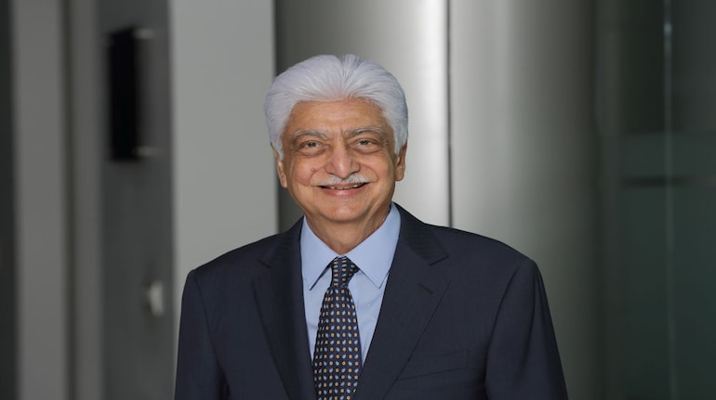

Azim Hashim Premji (born 24 July 1945) is an **Indian businessman, investor, engineer, and philanthropist, who was the chairman of Wipro Limited.** Premji remains a non-executive member of the board and founder chairman. He is informally known as the Czar of the Indian IT Industry

**Born:**Azim Hashim Premji; 24 July 1945 (age ...

**Occupation:**Founder chairman of [Wipro](http://en.wikipedia.org/wiki/Wipro)

**Parent(s):**Mohamed Hashem Premji

**Children:**[Rishad Premji](http://en.wikipedia.org/wiki/Rishad_Premji),

Indian business [entrepreneur](https://www.merriam-webster.com/dictionary/entrepreneur) who served as chairman of Wipro Limited, guiding the company through four decades of diversification and growth to emerge as a world leader in the [software](https://www.britannica.com/technology/software) industry. By the early 21st century, Premji had become one of the world’s wealthiest people. In the year that Premji was born, his father founded Western Indian Vegetable Products Ltd., which produced vanaspati, a widely used hydrogenated shortening. Three years later, colonial [India](https://www.britannica.com/place/India) was partitioned into mainly Hindu India and Muslim [Pakistan](https://www.britannica.com/place/Pakistan), but the Premjis, a Muslim family, chose to remain in India. In 1966, just before Premji was to complete his degree in engineering at [Stanford University](https://www.britannica.com/topic/Stanford-University), his father died unexpectedly. Postponing his graduation, he returned to India to take the reins of the family business and immediately began to diversify, [delving](https://www.britannica.com/dictionary/delving) into consumer products such as soap, shoes, and lightbulbs, as well as hydraulic cylinders.

Premji renamed the company Wipro in 1977, and in 1979, when the Indian government asked [IBM](https://www.britannica.com/topic/International-Business-Machines-Corporation) to leave the country, he began to steer the company toward the computer business. Wipro established a number of successful international partnerships in the 1980s to help it build computer hardware for sale in India. It was software development, however, that made the firm so lucrative. Premji built a reputation for hiring the best people and providing them with unparalleled training, and he took advantage of India’s large pool of well-educated software developers who were willing to work for much less money than their American counterparts. Wipro concentrated on developing custom software for export, primarily to the United States.

Thanks to substantial increases in [technology](https://www.britannica.com/technology/technology) stocks, Wipro’s value skyrocketed in the late 1990s, and Premji became one of the richest [entrepreneurs](https://www.merriam-webster.com/dictionary/entrepreneurs) in the world—a position he retained well into the 21st century. The success of both the company and its chairman was more than merely the result of outside forces’ inflating the value of the company, however. Premji had boldly broken with tradition by transforming Wipro into an information technology powerhouse with a solid footing in foreign markets at a time when most fortunes in India were based on ownership of land and factories used to produce domestically consumed goods. In 1999 Premji officially completed his degree from Stanford through a distance-learning arrangement.

Despite his vast personal wealth, Premji continued to be recognized for his modesty, lack of extravagance, and charity. In 2001 he established the nonprofit Azim Premji Foundation, through which he aimed to improve the quality of [elementary education](https://www.britannica.com/topic/elementary-education) in rural regions throughout India. By the end of the first decade of the 21st century, the foundation had extended computer-aided education to more than 16,000 schools, with child-friendly content increasingly available in local languages. Premji’s reputation remained that of a highly [ethical](https://www.merriam-webster.com/dictionary/ethical) entrepreneur whose operation served as a model for other Indian firms.